Syllabus: EarthSci 205 – The Planets

 Instructor: Prof. W. Panero
Office: Mendenhall 377
Office hours: Tuesdays 2:30-3:30 Mendenhall 377, and by appointment
Email: panero.1@osu.edu
Phone: 292-6290
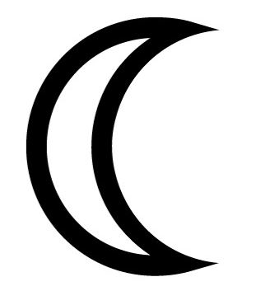TA: Dan Kelley
Office: Mendenhall 300
Office hours: M/Tu 11:30-12:30 and by appointment
Email: kelley.196@osu.edu
Phone: 292-3132
Course Goals
In ES205, we will explore our Solar System, study the origin and evolution of materials within it so that we may better understand our place in the Universe, the prospect of life elsewhere, and the destiny of humanity on Earth and in space.
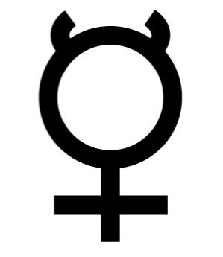Textbook:
The Planetary System (3rd edition) by D. Morrison and T. Owen
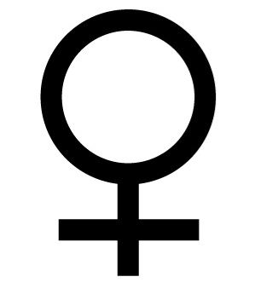Important Dates:
Planetarium Visit: Thursday, April 3, 12:30-2:18 pm
5th Floor, Smith Laboratory
Midterm Exam: Thursday, April 24, 12:30—2:18 pm
Final Exam: Wednesday, June 4 11:30 pm—1:18 pm

Lectures and Discussions
You will be responsible for the material presented in class, even if it is not in the text and vice versa. Lecture summaries, homework assignments, class information, and interesting Web links will be posted electronically on Carmen. These notes are intended as a supplement to the lecture to help you understand the class material, or as a make-up if you miss lecture. Each lecture will cover approximately one chapter in the textbook.
All cell phones must be turned off during class.
Participation in the discussion sections is required. At each discussion section there will be time for questions on the lectures, then a handout will be provided which includes exercises pertaining to that week’s activities. Completed assignments are due to the TA at the beginning of the next week’s discussion. No make ups for in-class exercises. Bring your textbook and calculator.
Late policy: Assignments will be marked 20% off for each day late, starting at 12:30 pm on the day due. Assignments submitted more than 5 days late receive no credit.

Schedule

Lectures: Orton 110, Tuesdays and Thursdays, 12:30-2:18 pm
Discussions: Mendenhall 252, Wednesday or Friday 12:30-2:18 pm

Week | Date | Topic | Reading
1 | Tue  Th  LAB | Scales of time and space and introduction to the solar system  Celestial mechanics and scientific theory  Earth-Moon-Sun system | Preface  Ch 1
2 | Tue  Th  LAB | The sun and electromagnetic radiation  Planetarium/telescope visit  **5th Floor, Smith Laboratory**  Distances and graphing | Ch 2  Ch 3
3 | Tue  Th  LAB | Planetary materials and matter  Meteorites: Messengers from the beginning  Meteorites; Orbits | Ch 4, 17  Ch 7
4 | Tue  Th  LAB | Moon  Lunar history: Dating cratered worlds  Mass and Density | Ch 7
5 | Tue  Th  LAB | Mercury and Moon: Tides & hints to planetary origins  Midterm examination  Radioactive Decay | Ch 8
6 | Tue  Th  LAB | The Blue Planet: How the Earth works  Mars  Cratering Density and Surface Ages | Ch 9  Ch 11
7 | Tue  Th  LAB | Venus  The outer solar system  Spectroscopy and the composition of the solar system | Ch 10  Ch 13,14
8 | Tue  Th  LAB | The Galilean moons  Saturn & Titan  Planetary science and the media | Ch 15
9 | Tue  Th  LAB | Origin of our solar system  Asteroids and comets  Planet Debate: Is Pluto a planet? | Ch 5,6  Ch 14
10 | Tue  Th  LAB | Planetary atmospheres and Astrobiology  Searching for other Earths and a new perspective on home  Final exam review | Ch 12  Ch 18

Final Exam: June 4, 11:30-1:18

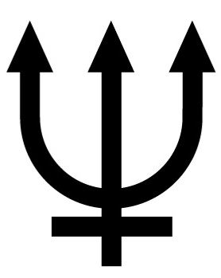 Exams
Exams will be a combination of multiple choice, short answer, and brief essay. You will not need a bluebook or a calculator (although you can bring one if you wish). The final will be cumulative, with about 1/3 covering material from before the midterm.

I realize that serious illnesses and emergencies happen. I require that you notify me of major illnesses or emergencies that prevent you from coming to class or lab. Missing an exam must be approved by me before the scheduled exam. My email and voicemail can receive a message at any hour of the day. I will likely require documentation for an absence at an exam.

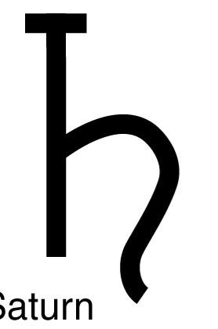 Disability Services
Students with disabilities that have been certified by the Office for Disability Services will be appropriately accommodated, and should inform the instructor as soon as possible of their needs. The Office for Disability Services is located in 150 Pomerene Hall, 1760 Neil Avenue (telephone 292-3307, TDD 292-0901, http://www.ods.ohio-state.edu/).
 Academic Misconduct:
The Ohio State University and the Committee on Academic Misconduct (COAM) expect that all students will complete all academic and scholarly assignments with fairness and honesty. Failure to follow the rules and guidelines established in the University’s Code of Student Conduct and this syllabus may constitute “Academic Misconduct”.

The Ohio State University’s Code of Student Conduct (Section 3335-23-04) defines academic misconduct as: “Any activity that tends to compromise the academic integrity of the University, or subvert the educational process”. Examples of academic misconduct include (but are not limited to) plagiarism, collusion (unauthorized collaboration), copying the work of another student, and possession of unauthorized materials during an examination. All suspected cases of academic misconduct will be reported to the University Committee on Academic Misconduct. If academic misconduct has been committed, possible sanctions could include a failing grade in this course and suspension or dismissal from the University.
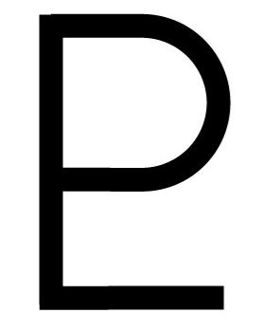Course Grading
Discussion exercises: 30% | A: ~90-100%
Moon exercise: 10% | B: ~80-89%
Midterm 25% | C: ~65-79%
Final 35% | D: ~50-64%
 | F: ~ below 50%
Grades will be curved if the course median score drops below 83%.

